

**Eastern Kentucky University**

**Taylor Fork Research Facility Disaster Plan**

Compiled by the Institutional Animal Care and Use Committee (IACUC)

Approved: September 2023

**TAYLOR FORK RESEARCH FACILITY**

**DISASTER PLAN**

**ABBREVIATIONS USED IN THIS MANUAL**

DVM = Doctor of Veterinary Medicine, medical professional for animals

IACUC = Institutional Animal Care & Use Committee

PI = Primary Investigator, usually faculty, who is ultimately responsible for a designated animal(s)

The Taylor Fork Ecological Area (TFEA) is a 60 acre site located near Eastern Kentucky University’s (EKU) main campus, which is used for teaching and research. The TFEA is administered by EKU’s Division of Natural Areas. A portion of the TFEA, designated as the Taylor Fork Research Facility, has a number of 20 gallon and 300 gallon cattle tanks which are used by faculty in EKU’s Department of Biological Sciences for aquatic animal research. The Taylor Fork Research Facility has been approved by EKU’s IACUC as a satellite animal facility. The Animal Welfare Act (Public Law 89-544 as amended) defines satellite areas as any building room, area, enclosure, or other containment outside of a [main] facility or centrally designated or managed area in which animals are housed for more than 12 hours. National Research Council’s Guide for the Care and Use of Laboratory Animals (8th edition, 2011) stipulates “Animal facilities may be subject to unexpected conditions …that severely compromise ongoing animal care and well-being. Facilities must therefore have a disaster plan…”.

**ANIMAL-RELATED EMERGENCIES DURING NORMAL WORKING HOURS**

For animal-related emergencies which occur during regular working hours (Monday thru Friday, 8am to 4:30pm), contact the Biology Department’s Administrative and Facilities Coordinator, Mr. Robert Pace. If Mr. Pace is not available, contact the Science Building Manager, Dr. Sherry Harrel. If neither Mr. Pace nor Dr. Harrel are available, contact the attending veterinarian, Bernard Doerning, DVM.

**ANIMAL-RELATED EMERGENCIES AFTER NORMAL WORKING HOURS**

Call 859-622-1111 (EKU Public Safety) for all animal-related emergencies which occur after normal working hours, during the weekend, or on holidays. Inform the dispatcher there has been an animal-related emergency at the Taylor Fork Animal Research Site and request the people listed with Public Safety as emergency contacts for animal-related emergencies be called.

**ADMINISTRATIVE & ANIMAL CARE PERSONNEL EMERGENCY CONTACT INFORMATION**

|  |  |
| --- | --- |
| **REGULAR BUSINESS HOURS** | **EVENING, WEEKEND, HOLIDAY** |
| Biology Department’s Administrative and Facilities Coordinator Robert Pace 859- 622-1533 | EKU Police/Public Safety  859-622-1111 |
| Biology Department Chair  Dr. Sherry Harrel 859-622-1531 | EKU Police/Public Safety  859-622-1111 |
| IACUC Veterinarian  Bernard Doerning, DVM 732-865-1215 | EKU Police/Public Safety  859-622-1111 |
| Taylor Fork Ecological Area Supervisor  Dr. David Brown 859-622-2283 | EKU Police/Public Safety  859-622-1111 |
| IACUC Chair  Dr. Charles Elliott 859-622-1538 | EKU Police/Public Safety  859-622-1111 |
| Environmental Health & Safety 859-622-3437 | EKU Police/Public Safety  859-622-1111 |
| Facilities Management 859-622-2966 | EKU Police/Public Safety  859-622-1111 |
| Student Health Services 859-622-1761 | EKU Police/Public Safety  859-622-1111 |

|  |  |
| --- | --- |
| Science Building & Vivarium Manager | sherry.harrel@eku.edu |
| IACUC Veterinarian | bjdoerning@gmail.com |
| Taylor Fork Supervisor | david.brown@eku.edu |
| IACUC Administration | lisa.royalty@eku.edu |
| IACUC Chair | [charles.elliott@eku.edu](mailto:charles.elliott@eku.edu) |

**FIRST PRINCIPLES**

* Human safety ALWAYS takes precedence over animal safety.
* The instructions of emergency authorities ALWAYS take precedence over the instructions of this Disaster Plan.
* In the event of an infectious disease pandemic campus closure, one or more of the individuals listed under Administrative & Animal Care Personnel will perform animal care duties or determine if animal depopulation is necessary in conjunction with the Principal Investigator(s).
* If evacuation of the Taylor Fork Research Facility is necessary, go to the Emergency Assembly Area location for the site, the memorial on the west side of the Ashland Building
* If all animals have perished in a disaster, efforts are for recovery only. In general, it will be up to the Administrative and Facilities Coordinator and/or Staff, escorted (after it has been deemed safe to enter) by emergency authorities, to determine the condition of animals in a building disaster.
* In general, carcasses are to be bagged, tagged, and refrigerated; the PIs consulted; and the carcasses disposed of according to university or city policy. If no refrigeration is available, a decision regarding the disposal of carcasses will be made in consultation with the emergency authorities on-site.
* When animals must be relocated, potential destinations are to be arranged, if the situation permits, in the following order of preference: (1) To another animal room within the vivarium; (2) To another room within the Science Building.
* In the event that surviving animals cannot be relocated, a decision concerning their fate will be made by one or more of the following personnel: the Primary Investigator (s), Administrative and Facilities Coordinator, or IACUC Veterinarian. Forced euthanasia criteria after a disaster include:
  + Being unable to feed or water the animals.
  + Being unable to keep the animals at an acceptable temperature range.
  + Being unable to keep the animals in an acceptable state of hygiene.
  + Euthanasia procedures will adhere to the latest AVMA Guidelines for the Euthanasia of Animals.

**READINESS (In General)**

Know the location of the following:

* Emergency contact information (located on the door of each animal room).
* Stairs and exits
* Fire alarms and extinguishers
* First aid kits (located in the hallway)
* Campus telephones (located in the hallway)

During an emergency evacuation employees/students should gather, as appropriate, in the following location(s):

* The Primary Evacuation Assembly Area (EAA) is the memorial on the west side of the Ashland Building.
* The Severe Weather Shelter is in the main hallway adjacent to room 117 in the Ashland Building.
  + If the Ashland Building is locked (after regular business hours) go to the nearest permanent structure and seek shelter on the lowest level, interior most portion, of the building.

**ADDRESSING SPECIFIC EMERGENCIES WHICH MAY OCCUR**

**AT THE TAYLOR FORK SITE**

**Fire:** In the event that a fire is reported in the area, immediately evacuate the area. If time permits, stop activities and secure the location. All animals will be left where they are. Evacuate the area and report to the main access gate near, the barn, to direct emergency responders to the approximate area of the fire.

**Power Failure**: If an unplanned power outage occurs, all animals will be left in their enclosures. Evacuate the area and come to the Science Building to report any utility outage to Facilities Management.

**Water Supply Problems**:If water for the Taylor Fork site is lost or gets contaminated, water will be brought in from an outside source. Report any utility outages to Facilities Management.

**Inclement Weather:** If access to the University is unsafe because of inclement weather, animals must be checked immediately upon access being restored.

**Tornado Warning:** When a tornado warning is issued, the emergency warning sirens will sound. Immediately evacuate the area and proceed to the Severe Weather Shelter in the main hallway adjacent to room 117 in the Ashland Building. If the Ashland Building is locked (after regular business hours) go to the nearest permanent structure. Move to an interior room on the lowest level of a sturdy building. Continue to monitor weather reports/conditions via mobile device, weather radio, etc. In the event of a tornado or severe weather, all animals will be left at the Taylor Fork site. If damage occurs to the site as a result of a tornado, the IACUC veterinarian shall determine whether the animals have been adversely affected enough whereby medical treatment or euthanasia is necessary.

**Flooding:** if flooding occurs, immediately evacuate the Taylor Fork site and contact the Taylor Fork Ecological Area Supervisor.

**Earthquake:** In the open, stay away from buildings, trees, telephone and electrical lines. In the event of an earthquake, all animals will be left in their enclosures. After the quake has subsided, the IACUC veterinarian shall determine whether the animals have been adversely affected enough whereby medical treatment or euthanasia is necessary.

**Off-Campus Chemical Release or Spill:** In the event of an off-campus chemical release or spill, the university will issue alerts via the emergency notification system**, if the emergency notification message instructs you to Shelter-In-Place, go immediately to the Perkins Building** and remain in the building until you are notified that the immediate danger has passed.

**TAYLOR FORK RESEARCH FACILITY**

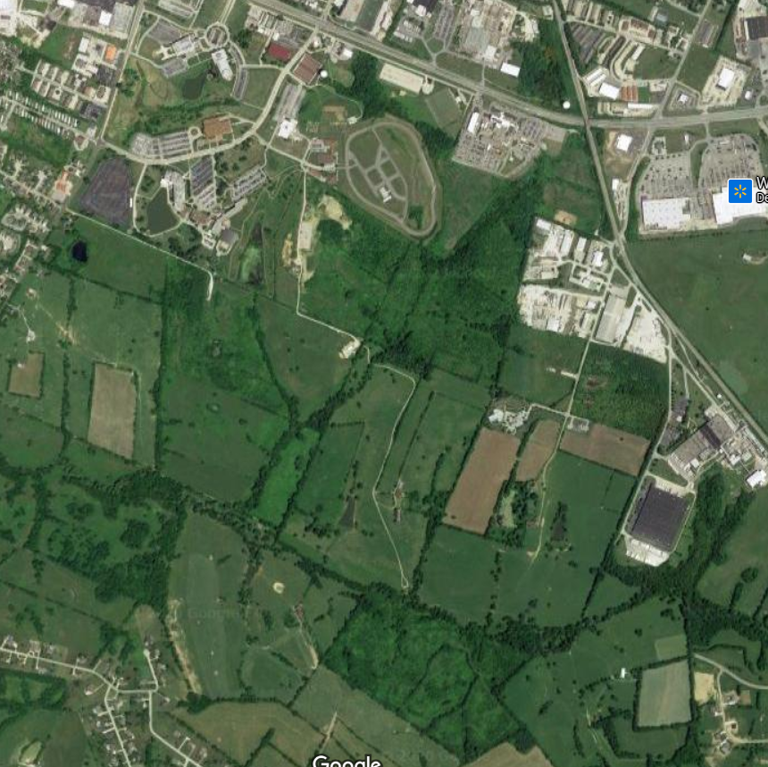**DIAGRAM**

TAYLOR FORK

ASHLAND BUILDING